Lab 4 Alex Arnold

Part 1

1.2.1 Balanced, High performance, Power saver

2.1.1 High performance

2.1.2 Turn off display after, Enable adaptive brightness

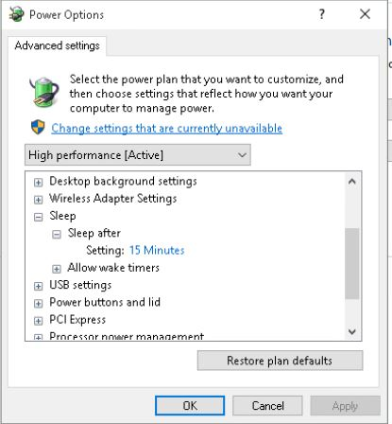

Power Option window

2.1.3 Optimize video quality, Balanced, optimize power savings

Balanced Plan

3 high performance is defaulted to never sleep where as Balanced is set to 30 min

Part 2

Programs and Features

Step 4

Step 7

Step 8

Advanced system settings

label Remote Desktop Management